Integration of EM Radiation Modeling in Electronic Circuit Simulators
Bessem Zitouna, Mohamed Tlig, Walid Labiadh, Sassia Hedia and Jaleleddine Ben Hadj Slama

Université de Sousse, Ecole Nationale d’Ingénieurs de Sousse, LATIS- Laboratory of Advanced Technology and Intelligent Systems, 4023, Sousse, Tunisie

Abstract—In this paper, we present an elegant method to include the prediction of radiated disturbances in electronic circuit-type simulators that allows performing electromagnetic (EM) radiation studies in both time and frequency domain. Indeed, circuit simulators are generally used to simulate conducted emissions for EM interferences analysis. Then, co-simulation based on numerical method platforms have to be investigated in order to consider radiated emissions. In the present work, the aim is to present a forward complementary tool that helps considering EM Compatibility (EMC) constraints from an early design stage by considering and generating radiated field distributions. The proposed method has been implemented in VHDL-AMS language using a top-down design flow. Determination of EM field emitted from the studied structure has been carried out analytically using expressions of radiated magnetic field at the level of each trace of the circuit. This method has been validated by performance comparisons between simulation results and measurements above a rectangular current loop. In a perspective of predicting and reducing electromagnetic interferences, integration of the developed generic module in any development and simulation environment, is an efficient solution to build a combined platform for both conducted and radiated emissions at the same time.

Keywords—Electromagnetic Compatibility (EMC), circuit simulator, PCB, radiated field, VHDL-AMS.

Introduction
Recently, designers and electronic research engineers are paying careful attention to Electromagnetic compatibility (EMC) issues from an early design cycle stage. It has been established that when problems are identified earlier, finding solutions can be easier since multiple low cost problem-solving techniques are possible [1-3]. Indeed, to deal with EMC problems from initial development steps, it is crucial to use prediction approaches starting from simulations to experimental tests.
In general, in power electronic systems, static converters are a major source of electromagnetic (EM) disturbances. In such structures, the propagation of this phenomenon happens in two ways: radiation mode and conduction mode [2-3]. In order to take into account these modes from the beginning, a detailed modeling of the different device elements has to be performed considering both the electrical operation of each system as well as and its electromagnetic behavior. This step is nothing else than performing a virtual prototyping that cannot be achieved without having powerful modeling tools [4-5]. These tools are divided into two categories, which are often used separately. On the one hand, there are circuit simulators (based on circuit’s laws), with fine components and connectors models. This category rely on multi-physics applications and allows conducted disturbances study [3][6-7]. On the other hand, there are electromagnetic simulator tools (based on Maxwell's equations) and these are dedicated for radiated disturbances studies [8-10].
Since EMC in Printed circuit board (PCB) is highly relevant, behavioral modeling of conducted emissions has been under investigation for many years. In recent research works, several researchers have developed equivalent electrical models for multiple components and systems [3] [11]. These models aim to mitigate conducted disturbances and are often already included in electronic circuit simulators; in particular, since the hardware description language VHDL-AMS has been successfully applied to behavioral modeling tasks [12-13]. However, the study of electromagnetic radiations using circuit simulators has been less discussed and investigated in research works. Indeed, in the literature, researchers have proposed radiating sources modelling for components or systems, but without considering conducted emissions in parallel [14-15]. The developed models do not require a considerable memory use, since they are mainly based on analytical developments using magnetic and electrical dipoles models. In addition, with the aim to simplify the prediction of EM radiation sources of device under test (DUT) and avoid possible couplings with neighboring systems, the proposed models need to be easily integrated in numerical resolution methods and in electromagnetic simulators [12]. It is worth noting that predicting and characterizing radiated emissions, in particular for complex structures, using numerical methods allow significant savings in developments time and cost [3]. However, it can be time and memory consuming since meshing is not always evident is such devices. Moreover, considering radiated disturbances should no longer be examined separately to conducted disturbances. In fact, radiation is just an image of conducted EM interferences (EMI) that has been created and propagated in the environment of the circuit through the antenna behavior of the studied PCB [16]. In general, conductive structures can behave at resonance frequencies as radiating antennas emitting a magnetic field when they are traversed by a variable current in short time and an electric field when it is about a variable electric potential [9-10]. These interferences are harmful and can lead to the system failure. Hence, conducted and radiated analysis at a time is a milestone in EMC studies.
Several EM simulation tools enable on their platform the integration of circuit simulator means by adding net-lists that connect discrete components to the radiating structure. Unfortunately, the opposite direction; integrating electromagnetic radiation frequency and time domain calculations in the circuit simulator, has not been widely developed. In addition, circuit’s simulation is possible using numerical methods and software, but the latter does not allow studying EM disturbances using circuit simulators. It is in this particular context that we present the current work. Indeed, the aim of this study is to allow forwardly EM analysis through circuit simulators in both time and frequency domain, using VHDL-AMS tool. This can help designers to correctly place the routings from the simulation phase due to the mitigation of loop effects, which is generated by PCB tracks.
In this paper, we propose to include radiated field modeling in circuit-type simulators. The present study consists in developing a generic model of magnetic field radiation of the device under test using VHDL-AMS. Indeed, when simulating the electrical quantities of the studied electronic circuit, magnetic field estimation is also provided. Hence, this article is organized as follows. First, theoretical investigations and the modelling methodology are presented in Section II. Simulation results has been also discussed using the proposed VHDL-AMS model, analytical equations and a numerical method based on the method of Moment (MoM). Then, in Section III, for further validation purposes, an experimental test is carried out using a current rectangular loop. A comparative study is performed using measurements and obtained results using the developed method in both time and frequency domain. Finally, Section IV concludes this paper.

Theoretical investigations and VHDL-AMS modeling

Theoretical Framework
In EMC studies, many tools are used to predict and reduce unwanted emissions in forms of radiation or conduction. On the one hand, for conducted disturbances, circuit simulator software, based on circuit equations and laws, allows fine-scale multi-physics modelling of the different components and connectors. On the other hand, radiated disturbances are investigated using electromagnetic simulation solutions mainly based on Maxwell equations. In the literature, several research works have proposed the use of basic equations of electromagnetism that describe EM field created by current and radiated by PCB traces, either in time or frequency domain. In the present work, since we aim to integrate the developed model in a circuit simulator whose resolutions are in time domain, we have employed TD EM equations.
In PCBs, any conductive path is defined by its two ends A and B, and by the current I which is flowing in it. We assume that the length of this trace is very important in comparison with its width. In this case, the current distribution is of a filiform type and it is difficult to provide a forward and accurate calculation of the radiated magnetic field. Hence for electrically long traces, we consider that the initial path is nothing than a composition of multiple short traces dl, which are negligible in front of the wavelength, as shown in Figure 1. In [17-18], authors have presented expressions for the calculation of radiated magnetic field (Hx, Hy and Hz). Those generated from the PCB short traces dl and obtained at a measurement point M (Xm, Ym, Zm), are as following:
$H_{x}= \sum_{AB}{\frac{\left(Z_{M}-Z_{A}\right)}{4π}}\int_{Y_{A}}^{Y_{B}}{TdY}$ (1)
$H_{y}= -\sum_{AB}{\frac{\left(Z_{M}-Z_{A}\right)}{4π}}\int_{X_{A}}^{X_{B}}{TdX}$ (2)
$H_{z}= \sum_{AB}{\frac{1}{4π}}\left(\left(Y_{M}-Y_{A}\right)\int_{X_{A}}^{X_{B}}{TdX}-\left(X_{M}-X_{A}\right)\int_{Y_{A}}^{Y_{B}}{TdY}\right)$(3)

$T=I\frac{\cos{βR}}{R^{3}}+ \frac{dI}{dt}\sqrt{ε_{0}μ_{0}}\frac{\sin{βR}}{R^{2}}$ (4)
where $β=2 π\frac{f}{c},with c=3 {10}^{8} m/s$ and R is the Euclidean distance between the observation point M and the PCB trace.

A (X_{A}, Y_{A}, Z_{A})
B (X_{B}, Y_{B}, Z_{B})
dl
R
M
X
Z
Y
I
Figure 1. Elementary partition of a PCB trace.

Behavioral Modeling Approach using VHDL-AMS
Modeling and simulation are at the core of each design process. Hence, IEEE has put great efforts in extending VHDL so that it can support modeling and simulation of any analog and mixed-signal systems (AMS). These efforts came to fruition with the release and creation of VHDL-AMS [12-13][19]. Among the advantages of programming in VHDL-AMS is the fact that it supports differential and algebraic equations, even those that include discontinuities. In this work, the three equations of the magnetic field are coded to describe and verify the behavior of the structure.

ENTITY pcb_ray IS
Generic (
Xa : real := 1.0 ;
Ya : real := 2.0 ;
Za : real := 3.0 ;
Xb : real := 1.0 ;
Yb : real := 2.0 ;
Zb : real := 3.0 ;
Xm : real := 3.0 ;
Ym : real := 2.0 ;
Zm : real := 1.0 ;
Port (
Terminal p, m : electrical ;
Quantity Hxp, Hyp, Hzp : out real );
END pcb_ray;

Figure 2. Entity instantiation of a PCB trace.

In general, a VHDL-AMS model consists of an entity and one or more architectures. First, the model interface is instantiated in the entity, including the different ports and generic parameters. For the proposed PCB trace model, the entity is defined as shown in Figure 2. It contains: in the generic field; the default set of parameters of necessary coordinates and in the port field; electrical terminals and the three magnetic fields components. In the VHDL-AMS source code of the studied structure, we define upon use the extremity points’ coordinates A and B of the modeled PCB trace, the number of subdivisions N and the coordinates of the point M, where one wishes to calculate the radiated magnetic field. Then, we assign values for each parameter.

Simulation Results
For validation purposes, first, we propose to apply our VHDL-AMS modeling approach to a simulation test case. The studied structure is a basic rectangular current loop, defined by placing four PCB traces, Figure 3. Indeed, understanding and studying loop effects is a common concern for EMC engineer and researchers [20-21]. In power electronic systems, in particular for nonlinear devices, EM disturbances are mainly generated by voltage and current commutations, which create critical nonintentional transient perturbations. In this case, transient sources cover a wide frequency band and radiation characterization become highly required [17-18]. In order to reproduce a similar radiation behavior, we have used a transient excitation current (a non-sinusoidal temporal signal), as shown in Figure 4. Then, the proposed VHDL-AMS model has been applied to generate NF radiation maps. As depicted in Figure 5, the VHDL-AMS model of the studied current is based on the four PCB traces specifications. Radiated magnetic field is obtained by calculations above a rectangular loop of 5 cm length and 3 cm width, placed in the XY plane (Z = 0). Furthermore, the measurement surface of (5 cm x 3 cm) dimensions is placed at height h of 10 mm above the structure. A displacement step of 5 mm on the X-axis and 3 mm on the Y-axis has been defined (111 calculation points in total). Then, we propose to compare these results to those obtained using either a numerical or an analytical method.

Y
P3 (3,0,0)
P (0,0,0)
P2 (3,5,0)
P1 (0,5,0)
X
I
Figure 3. Studied rectangular current loop.

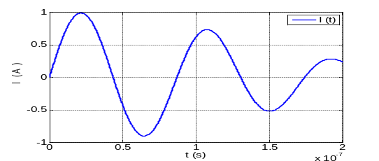
Figure 4. Non-sinusoidal excitation signal.

Obtained VHDL-AMS model results are compared to those obtained by a numerical method. For this, we have investigated the use of the Numerical Electromagnetics Code (NEC) software [22], based on the method of moments (MoM) [23]. The latter is well-known numerical method in computational electromagnetics [23]. Figure 6 presents a comparison of the estimated magnetic field maps using both methods in the frequency domain at f = 10 MHz. In Figure 7, cuts of magnetic field components Hx, Hy and Hz are depicted along X-axis and Y-axis and for y=6mm ; x=10mm. Good agreement has been obtained between estimated magnetic field using the proposed VHDL-AMS model and the MoM method at both the field distribution and magnitudes.

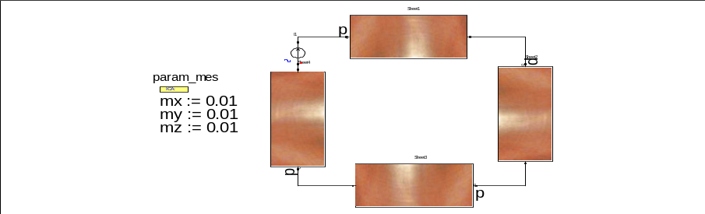
Figure 5. VHDL-AMS model of the studied structure.

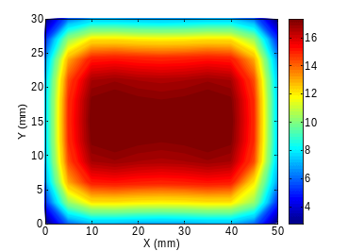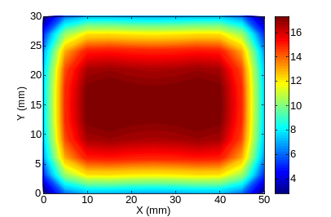
VHDL-AMS model
MoM method

Figure 3. Estimated magnetic field (Hz) map using VHDL-AMS model and method of moments at f = 10 MHz (in dB μA/m).

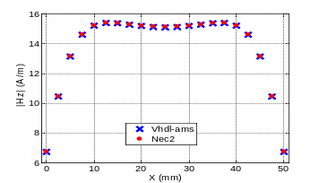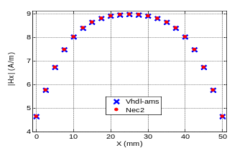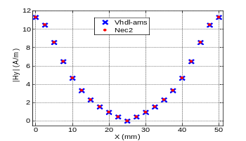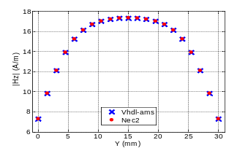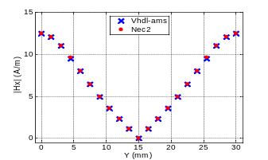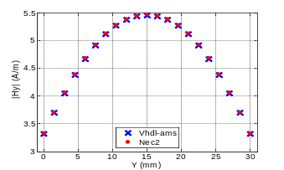
Hx
Hz
Hy

Figure 7. Cuts of Hx,y,z along X-axis and Y-axis: for y=6mm ; x=10mm.
After numerical verifications, it is a good practice to perform analytical verifications either in time or frequency domain. Hence, we compare obtained results using our VHDL-AMS model and analytical equations describing the magnetic field radiation of the studied rectangular loop in time domain. Indeed, magnetic fields emitted by the loop in a measurement point M (x, y, z) are given by summing obtained signals for each PCB trace of the circuit, as explained in subsection A. Calculated magnetic field signals using the proposed model and analytical expressions at three positions M1 (10mm, 10mm, 10mm), M2 (20mm, 20mm, 10mm), and M3 (10mm, 10mm, 1m), are plotted on Figure 8. Looking at this figure, we observe adequate agreement between both methods at different heights of measurements even when increasing the distance between the circuit and the calculation point position. Obtained TD signals have the similar waveforms and field intensity.

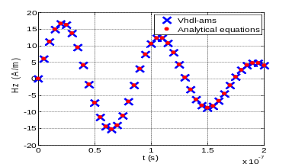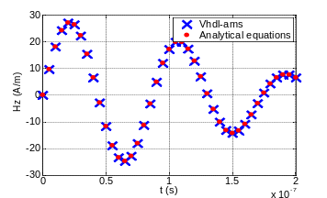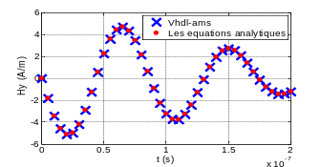
M1 (0,01,0.01,0.01)

M2 (0,02,0.02,0.01)

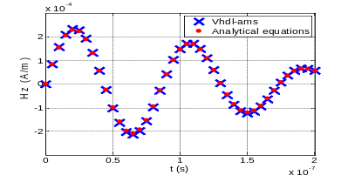
M3 (0,01,0.01,1)

Figure 4. Magnetic field Hz at different positions (in m).
Looking at Figures 7 and 8, we conclude that our VHDL-AMS model is an efficient approach and valid in particular when dealing with transient excitation signal. In fact, the proposed mothod provides similar results as numerical and analytical methods in both frequency and time domain.

EXPERIMENTAL VALIDATION

Near-Field Measurement Test Bench
In order to verify the simulation correctness of the previous simulations, the practical conduct of the present work requires performing experimental measurements using a NF test bench. Indeed, the test setup consists of three components:
- A displacement mechanical structure, responsible for the movement along the XY plane, such as an automated machine or a plotting table.
- A magnetic probe for measuring the magnetic field. This probe is electrically small so that current is constant around the loop. Measured field only depends on current and area (coil loop radius). Probe calibration and signal synchronization has been explained in [10].
- Acquisition system; eventually a computer is needed to monitor the movement of the probe in the predefined area and with a chosen displacement step. This computer is connected a Lecroy Wave Runner 104XI oscilloscope.
Configuration parameters, such as the height of measurement, are defined by the bench user (regarding the specifications of the device under test). A detailed study of this measurement test bench has been presented in [10]. Figure 9 shows an overview of test setup.

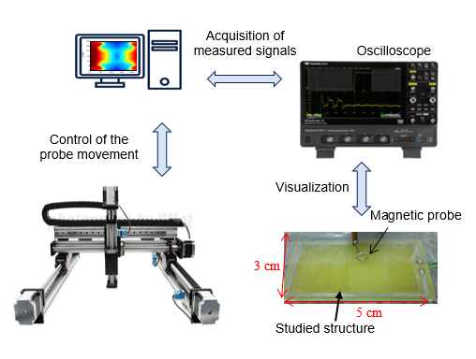
Figure 5. Near-Field measurement test bench.

Studied Structure
In order to reproduce similar radiation behavior of current loops in real power electronic systems, TD measurements have been carried out above an academic structure. Indeed, as in the case of simulation tests in Section II, a (5 cm x 3 cm) rectangular loop has been excited using a current coming from a buck converter with a switching a MOSFET, with a ratio of cyclic to 0.5 and supplied by a voltage of 30 V. The switching frequency is 50 kHz and the current delivered to the load is 0.65 A. The loop under test is depicted in Figure 10.
The radiated magnetic field has been measured at 5 mm above the studied structure. The movement of the measuring probe has been with a displacement step of 5 mm along the X axis and a step of 3 mm on the Y axis, with a total of 111 scanning points. In addition, we measured the current flowing in the loop, Figure 11. Hence, we used a shunt resistor of 0.0244 Ω. Indeed, this current will be introduced to our VHDL-AMS model to be employed as an excitation signal. Afterwards, using the proposed module, we calculate magnetic field components radiated by the loop at different points in space, at the same height of measurement (scan surface). Finally, we compare the estimated magnetic field to the one measured above the loop. Comparisons are carried out in both time domain and frequency domain.

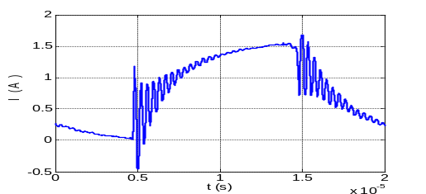
Figure 11. Measured current flowing through the loop with the shunt.

Time Domain Validation
As we get closer to the radiating source (near field), the field produced is mainly a function of the properties of this source. In practice, to measure near-field radiated emissions, we use a magnetic NF probe. The magnetic field passing through this probe loop generates a voltage (Farady’s law). This induced voltage is proportional to the rate of change of magnetic flux through the circuit loop. Hence, the measured magnetic field in the coil of the NF probe can be obtained from its voltage output signal, as explained in [10] [24]. Calculations provide the average magnetic field that is enclosed by the probe coil. Since we use an oscilloscope in our measurement test bench, temporal signals are forwardly acquired. In parallel, using the proposed VHDL-AMS model, we can calculate the three magnetic field components Hz, Hx and Hy. In the following, we perform simple calculations to extract the simulated voltage by our model across the probe in order to compare it to that measured above the loop.
Figures 12 to 14 respectively show a comparison between VHDL-AMS model estimation results and measured signals at the probe terminals Vz, Vx and Vy at a point M of coordinates (5mm, 6mm, 5mm). As shown in the figures bellow, a very good agreement between temporal voltages signals across the probe using measurements and the developed VHDL-AMS module.

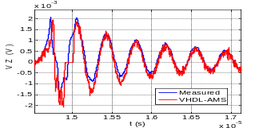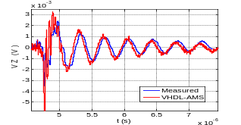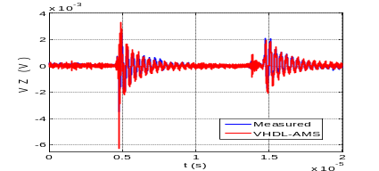
Figure 12. Comparison between obtained voltage signals Vz.
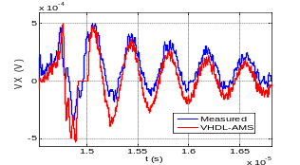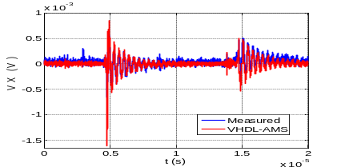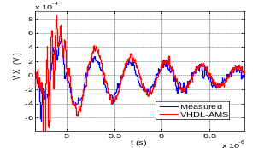

Figure 13. Comparison between obtained voltage signals Vx.
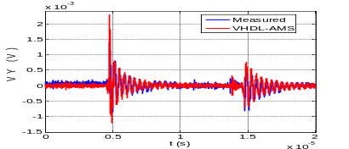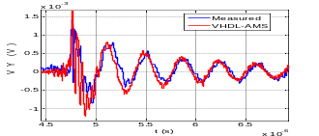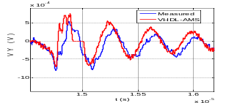
Figure 14. Comparison between obtained voltage signals Vy.

Frequency Domain Validation
During circuit operation, signals are travelling through circuit loops. The larger the loop, the stronger the harmonic and fundamental emissions will be. Indeed, in the frequency domain, it is a difficult task to extract the different radiating sources simultaneously. However, it is important to assess the studied structures at some frequencies. In order to validate the proposed model in the FD, we carry out a Fast Fourier Transformation (FFT) of the measured magnetic field signals and of course to those obtained by our model at all measurement points of the scan surface [24]. Therefore, a radiation distribution map is acquired at each defined frequency.
Figure 15 presents a comparison between measured and estimated magnetic field radiations maps using the proposed VHDL-AMS method at f = 3 MHz. We notice the conformity between these field cartographies for each field component in both amplitude field and distribution levels. In addition, examining the various results, we can see that the estimation of the magnetic field the VHDL-AMS module has been carried out with good accuracy.

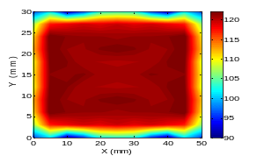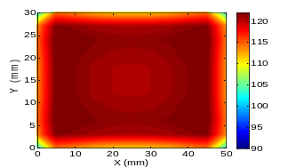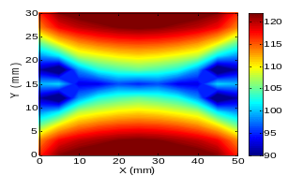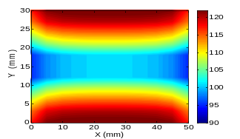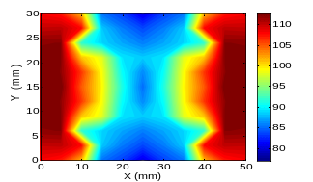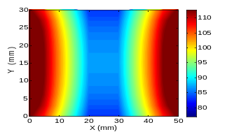
Hy
VHDL-AMS model
Measured maps
Hz
Hx
Figure 15. Obtained radiation maps at f=3MHz (dB μA/m).

In Summary, to improve EMC at circuit level, the proposed VHDL-AMS method is a powerful tool when dealing with magnetic field assessment in both time and frequency domain. It is also a complementary way allowing combining conducted and radiated emissions study simultaneously and it is able to answer to a large part of EMC issues that requires minimizing possible loop areas.

Conclusion
The aim of the present work is to include radiated emissions investigations in electronic circuit simulators using VHDL-AMS modeling. Magnetic field signals emitted by PCB traces have been determined using analytical equations describing radiated emissions. For validation purposes, a comparative study has been carried out. The proposed model has proven its efficiency through various simulation and experimental tests in both time and frequency domain. A good accuracy has been obtained and similar magnetic field distributions have been generated. The developed VHDL-AMS model provides a rapid estimation of magnetic field distributions at the same time as the calculation of electrical quantities of the circuit by the simulator. It enables optimizing the design of the circuit to minimize possible loops areas and predict radiation sources in power electronic applications. The proposed method allows circuits designers to modify the circuit layout in order to find the best arrangements of components and tracks that mitigate radiated emissions or orient them to reduce couplings effects. Moreover, this modeling approach allows avoiding co-simulation platforms that are time and memory consuming while mesh generation in numerical analysis methods. Therefore, radiated disturbances study should no longer be carried out separately from conducted disturbances. In fact, radiated emissions are the image of conducted field that flourish in the surrounding of the studied circuit thanks to the different conductive structures including PCB tracks.

References
- Besnier, P., Delaporte, F., & Houret, T. “Extreme Values and Risk Analysis: EMC Design Approach Through Metamodeling”. IEEE Electromagnetic Compatibility Magazine, 10(4), 80-93.
- Kiefer, F., Holste, K., Klar, P. J., Rover, Y., Probst, U., & Volkmar, C.. “Reverberation chamber for electromagnetic compatibility testing of electric thrusters”. Journal of Electric Propulsion, 2(1), 1-14.
- Kharanaq, Fatemeh Abolqasemi, Ali Emadi, and Berker Bilgin. "Modeling of conducted emissions for EMI analysis of power converters: State-of-the-art review." IEEE Access 8 (2020): 189313-189325.
- Pescari, Catalin, et al. "On Using EMC Simulation for Solving Power Integrity Issues." 2022 14th International Conference on Communications (COMM). IEEE, 2022.
- Zagkanas, Vasileios N., et al. "11‐4: Invited Paper: Virtual Prototyping and Testing of Automotive Capacitive Touch Sensors." SID Symposium Digest of Technical Papers. Vol. 51. No. 1. 2020.
- Kraiem, Sana, Jaleleddine Ben Hadj Slama, and Mahmoud Hamouda. "Conducted EMI Reduction in Transformerless PV Grid-Connected Inverter Based on PCB Improvement." 2021 12th International Renewable Energy Congress (IREC). IEEE, 2021.
- Hrigua, Slim, et al. "New modeling method based on transfer functions for EMI analysis in power electronic converters." International Symposium on Electromagnetic Compatibility-EMC EUROPE. IEEE, 2012.
- Lévy, Pierre-Etienne, et al. "Accurate modeling of radiated electromagnetic field by a coil with a toroidal ferromagnetic core." IEEE transactions on electromagnetic compatibility 55.5 (2013): 825-833.
- Zitouna, Bessem, and Jaleleddine Ben Hadj Slama. "Time domain inverse method based on the near field technique to solve electromagnetic interference problems: application to an AC/DC flyback converter." IET Power Electronics 11.13 (2018): 2133-2139.
- Hedia, Sassia, et al. "Electromagnetic Time Reversal in the Near Field: Characterization of Transient Disturbances in Power Electronics." IEEE Transactions on Electromagnetic Compatibility 62.5 (2020): 1869-1878.
- Baba, Tamana, Nurul Arfah Che Mustapha, and Nurul Fadzlin Hasbullah. "Noise Sources Extraction for Conducted Emission Modeling of IC’s using IBIS Models." 2021 8th International Conference on Computer and Communication Engineering (ICCCE). IEEE, 2021.
- Hami, Fahim, et al. "Wideband impedance characterization and modeling of power electronic capacitors under high bias voltage variation." 2014 International Symposium on Electromagnetic Compatibility. IEEE, 2014.
- Allard, Bruno, Herve Morel, and Sabrine MRad. "VHDL-AMS model of IGBT for electro-thermal simulation." 2007 European Conference on Power Electronics and Applications. IEEE, 2007.
- Shall, Hanen, Zouheir Riah, and Moncef Kadi. "A 3-D near-field modeling approach for electromagnetic interference prediction." IEEE Transactions on Electromagnetic Compatibility 56.1 (2013): 102-112.
- Ravelo, Blaise, Yang Liu, and Adam K. Jastrzebski. "PCB near-field transient emission time-domain model." IEEE Transactions on Electromagnetic Compatibility 57.6 (2015): 1320-1328.
- Tong, Xin, et al. "Modeling electromagnetic emissions from printed circuit boards in closed environments using equivalent dipoles." IEEE Transactions on Electromagnetic Compatibility 52.2 (2010): 462-470.
- Zitouna, Bessem, and Jaleleddine Ben Hadj Slama. "Enhancement of time-domain electromagnetic inverse method for modeling circuits radiations." IEEE Transactions on Electromagnetic Compatibility 58.2 (2016): 534-542.
- Hedia, Sassia, et al. "A full time domain methodology based on near field time reversal for equivalent source identification." 2018 IEEE International Symposium on Electromagnetic Compatibility and 2018 IEEE Asia-Pacific Symposium on Electromagnetic Compatibility (EMC/APEMC). IEEE, 2018.
- Slama, Jaleleddine Ben Hadj, and Walid Labiedh. "Library of EMC models for passive components and printed circuit board." 2012 16th IEEE Mediterranean Electrotechnical Conference. IEEE, 2012.
- Ruddle, Alastair R., Lester Low, and Andrea Vassilev. "Evaluating low frequency magnetic field exposure from traction current transients in electric vehicles." 2013 International Symposium on Electromagnetic Compatibility. IEEE, 2013.
- Kovačević, Ivana F., et al. "3-D electromagnetic modeling of parasitics and mutual coupling in EMI filters." IEEE Transactions on Power Electronics 29.1 (2013): 135-149.
- Xue, Haoyan, Akihiro Ametani, and Kazuo Yamamoto. "Theoretical and NEC calculations of electromagnetic fields generated from a multi-phase underground cable." IEEE Transactions on Power Delivery 36.3 (2020): 1270-1280.
- Pelosi, Giuseppe, Antonio Savini, and Stefano Selleri. "A Brief History of Computational Electromagnetics." 2021 7th IEEE History of Electrotechnology Conference (HISTELCON). IEEE, 2021.
- Tlig, Mohamed, J. Ben Hadj Slama, and Mohamed Ali Belaid. "Conducted and radiated EMI evolution of power RF N-LDMOS after accelerated ageing tests." Microelectronics Reliability 53.9-11 (2013): 1793-1797.

